Reference Source | Picture | Information | Layout
Dictionary | 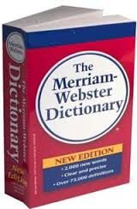 | Contains words in alphabetical order and gives meanings, parts of speech, and pronunciations. Information can be located using guide words on each page
Thesaurus | 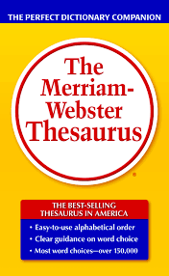 | Contains synonyms and antonyms of words in alphabetical order
Encyclopedia | 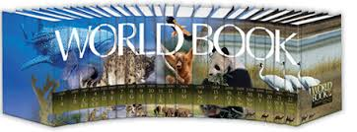 | Contains information about people, places, things, ideas, events, animals, etc. Information in the encyclopedia is in alphabetical order and grouped together. Use the guide words at the top of the page to find your topic
Atlas | 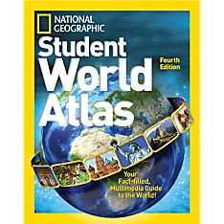 | Contains maps and information about land
Almanac | 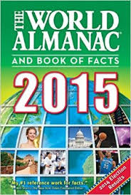 | Contains information about important events or records that happened during a specific year
Nonfiction books |  | Contains specific information that is true | 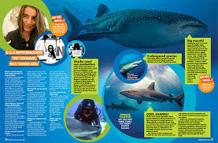
Internet Search Engines | 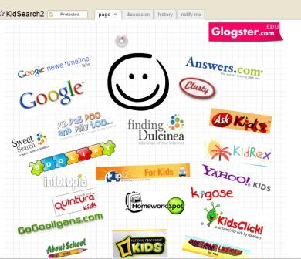 | A special tool that will generate a list of websites that contains information on a keyword or topic that you type in | 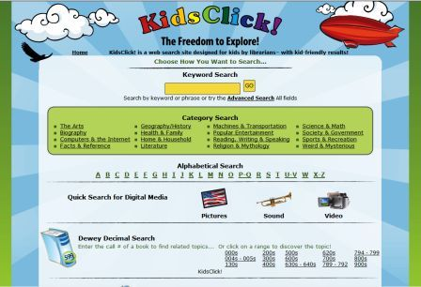
Internet Database |  | Subscription-only information that is not available through free search engines. The information is carefully checked for accuracy.
Magazines | 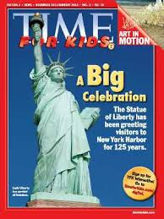 | Contains essays, stories, poems, nonfiction articles by many authors, and often contains photographs or drawings. They are issued periodically and are usually specialized in a particular topic.
Newspaper |  | Contains information about current events in the news, comments, features, and advertising. It is usually issued daily or weekly. | 